- The UK’s poor fiscal position leaves it more vulnerable than many other countries to global shocks. This means that UK governments need a strong, coherent narrative and policies that will sustainably improve the fiscal position to maintain market confidence.
- However, the current administration has struggled to develop a credible story and to take steps to reverse the ebbing confidence, which means the latest political upheaval risks driving a steepening of the curve.
- Though UK government gross debt is lower than most other G7 countries, its relative lack of public sector assets means the net debt position is much weaker. In addition, debt has risen sharply since 2007. Countries with much higher levels of debt can take advantage of structural benefits the UK doesn’t share.
- The UK has one of the highest budget deficits in the G7, and the government’s plan to reduce borrowing lacks credibility. Tax-based consolidations have a high failure rate, a risk increased by the focus on small revenue streams. What’s more, its history of pushing back planned tightening further undermines credibility, particularly given some of the measures are due to be implemented in an election year.
- Successive governments have struggled to tackle persistently high inflation and weak productivity growth. Regular political upheaval and increasingly populist discourse make it harder to drive the necessary reform. As a result, the UK has not yet found a route out of its damaging debt dynamics.
We argued recently, that most of the rise in UK gilt yields this year is a response to the Middle East conflict, with markets anticipating that tighter monetary policy will be needed to limit second-round effects from the energy shock. Here, we analyse why the UK could face a steepening of the yield curve once short-end pressures fade.
Chart 1: The UK's debt dynamics are weaker than those of most other advanced economies
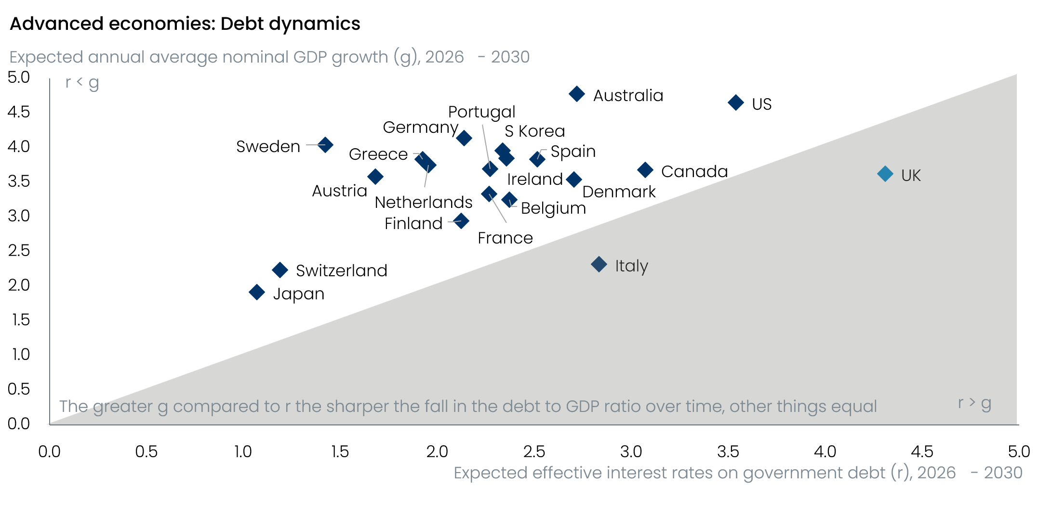
Source: Oxford Economics

Debt has risen a lot in the past 20 years
Of the G7 countries, only Germany has a lower level of general government gross debt than the UK. But other countries have much higher levels of assets, so the UK’s net debt position is weaker than all G7 countries apart from the US and Italy (Chart 2). Furthermore, the UK debt level has risen sharply in the crises of the past 20 years. Before the global financial crisis, net debt was typically around 30%-40% of GDP; now it’s above 90% (Chart 3).
Chart 2: The UK has one of the higher levels of net debt compared with other G7 countries
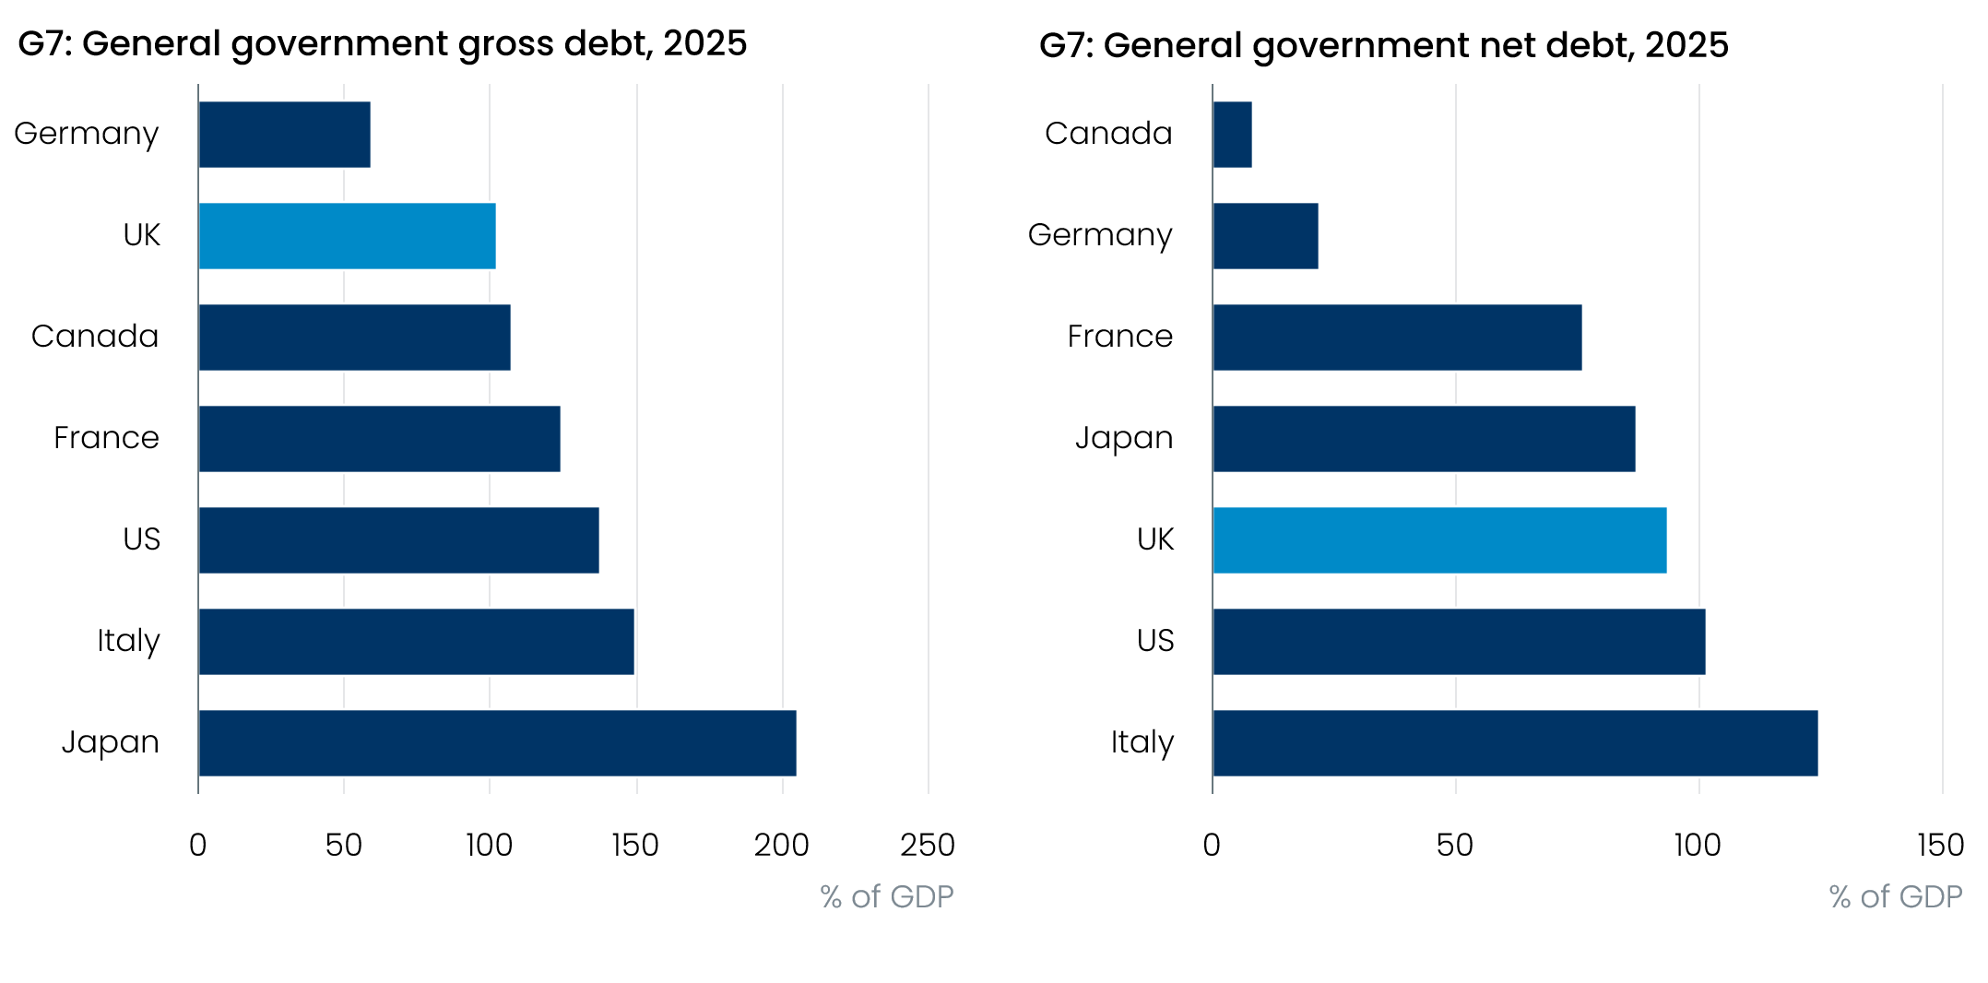
Sources: Oxford Economics, Haver Analytics
Chart 3: The GFC, pandemic, and 2022-2023 energy shock all caused debt levels to ratchet upwards
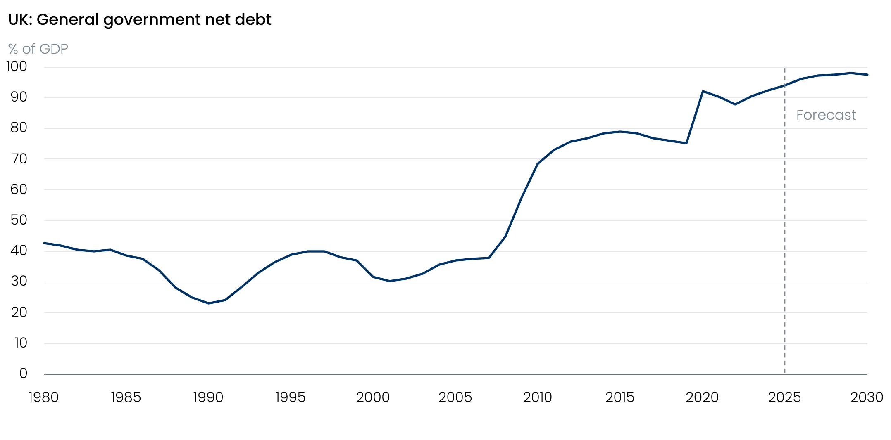
Sources: Oxford Economics, Haver Analytics

UK debt servicing costs are at levels not seen for more than 30 years
Countries with much higher levels of debt can take advantage of structural benefits that the UK doesn't share. In Japan, domestic savers provide strong demand for Japanese government debt; in Europe, the European Central Bank effectively acts as a backstop for Eurozone countries; and the US has the world's reserve currency. By contrast, a greater proportion of UK government debt is held by foreign investors than is the case in most other countries, leaving the UK more reliant on the kindness of strangers.
At the same time, around a quarter of the UK’s debt stock is index-linked. This is a much higher share than most other countries – the US share is around 10% and most other countries at less than 5%. In the current higher inflation era, greater use of index-linked bonds has meant the UK’s debt interest bill has increased by more than other countries with smaller exposure.
The combination of a steep rise in the level of debt, higher yields, and higher inflation has meant that the UK’s debt servicing bill has climbed sharply in recent years. In FY2025-26, debt interest payments were 3.6% of GDP – a level not seen on a sustained basis since the mid-1980s (Chart 4). Similarly, interest payments are currently around 9% of government revenues; in the decade before the pandemic this ratio averaged 5.5%.
Chart 4: Debt servicing costs have risen sharply due to higher debt levels, gilt yields, and inflation
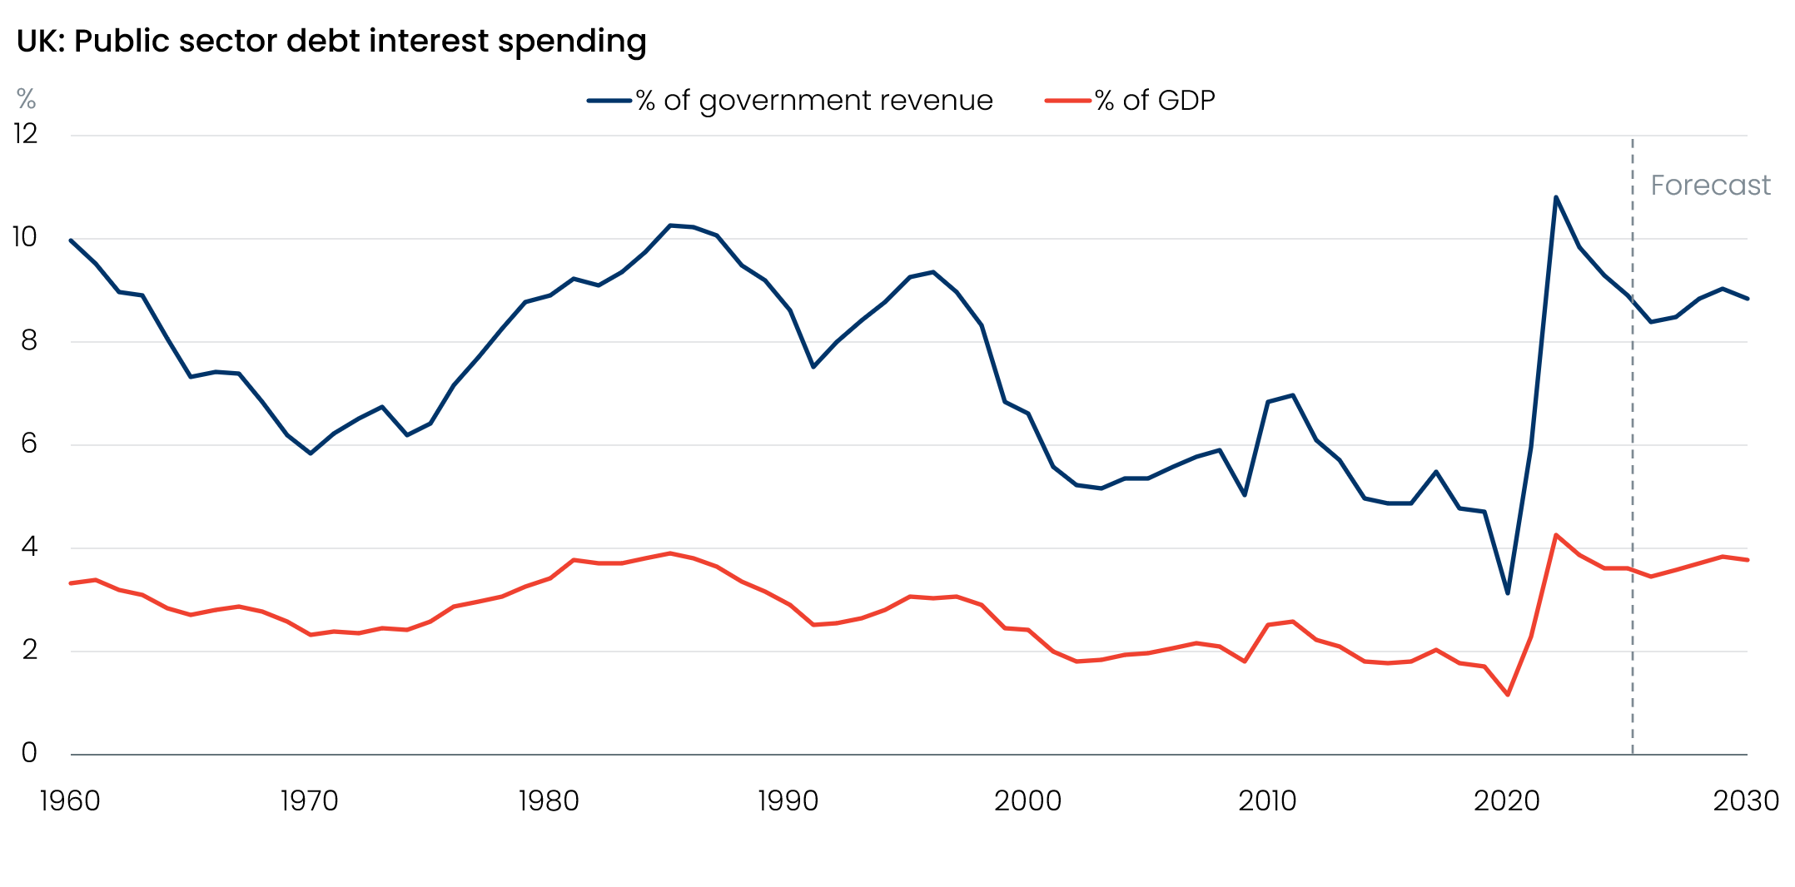
Source: Office for Budget Responsibility

Fiscal policy credibility has been undermined by soft pedalling and unconvincing plans
The UK has one of the highest budget deficits in the G7. What’s more, the UK deficit has been stuck in the 4%-5% range since 2021. This is partly because successive governments have announced plans to tighten policy over the period covered by the fiscal rules, but then watered down those plans over time, promising to catch up with further tightening in the future.
In the March 2022 Budget, Conservative chancellor Rishi Sunak announced fiscal plans that the Office for Budget Responsibility forecast would cut public sector net borrowing to 1.2% of GDP in FY2025-26 (Chart 5). By the last Conservative budget in March 2024, the OBR’s forecast for FY2025-26 had risen to 2.7% of GDP. The incoming Labour government loosened the fiscal rules and then allowed the consolidation to slip further, and in the event, borrowing was 4.3% of GDP in the fiscal year just finished.
Chart 5: Consolidation plans have been consistently delayed over recent years
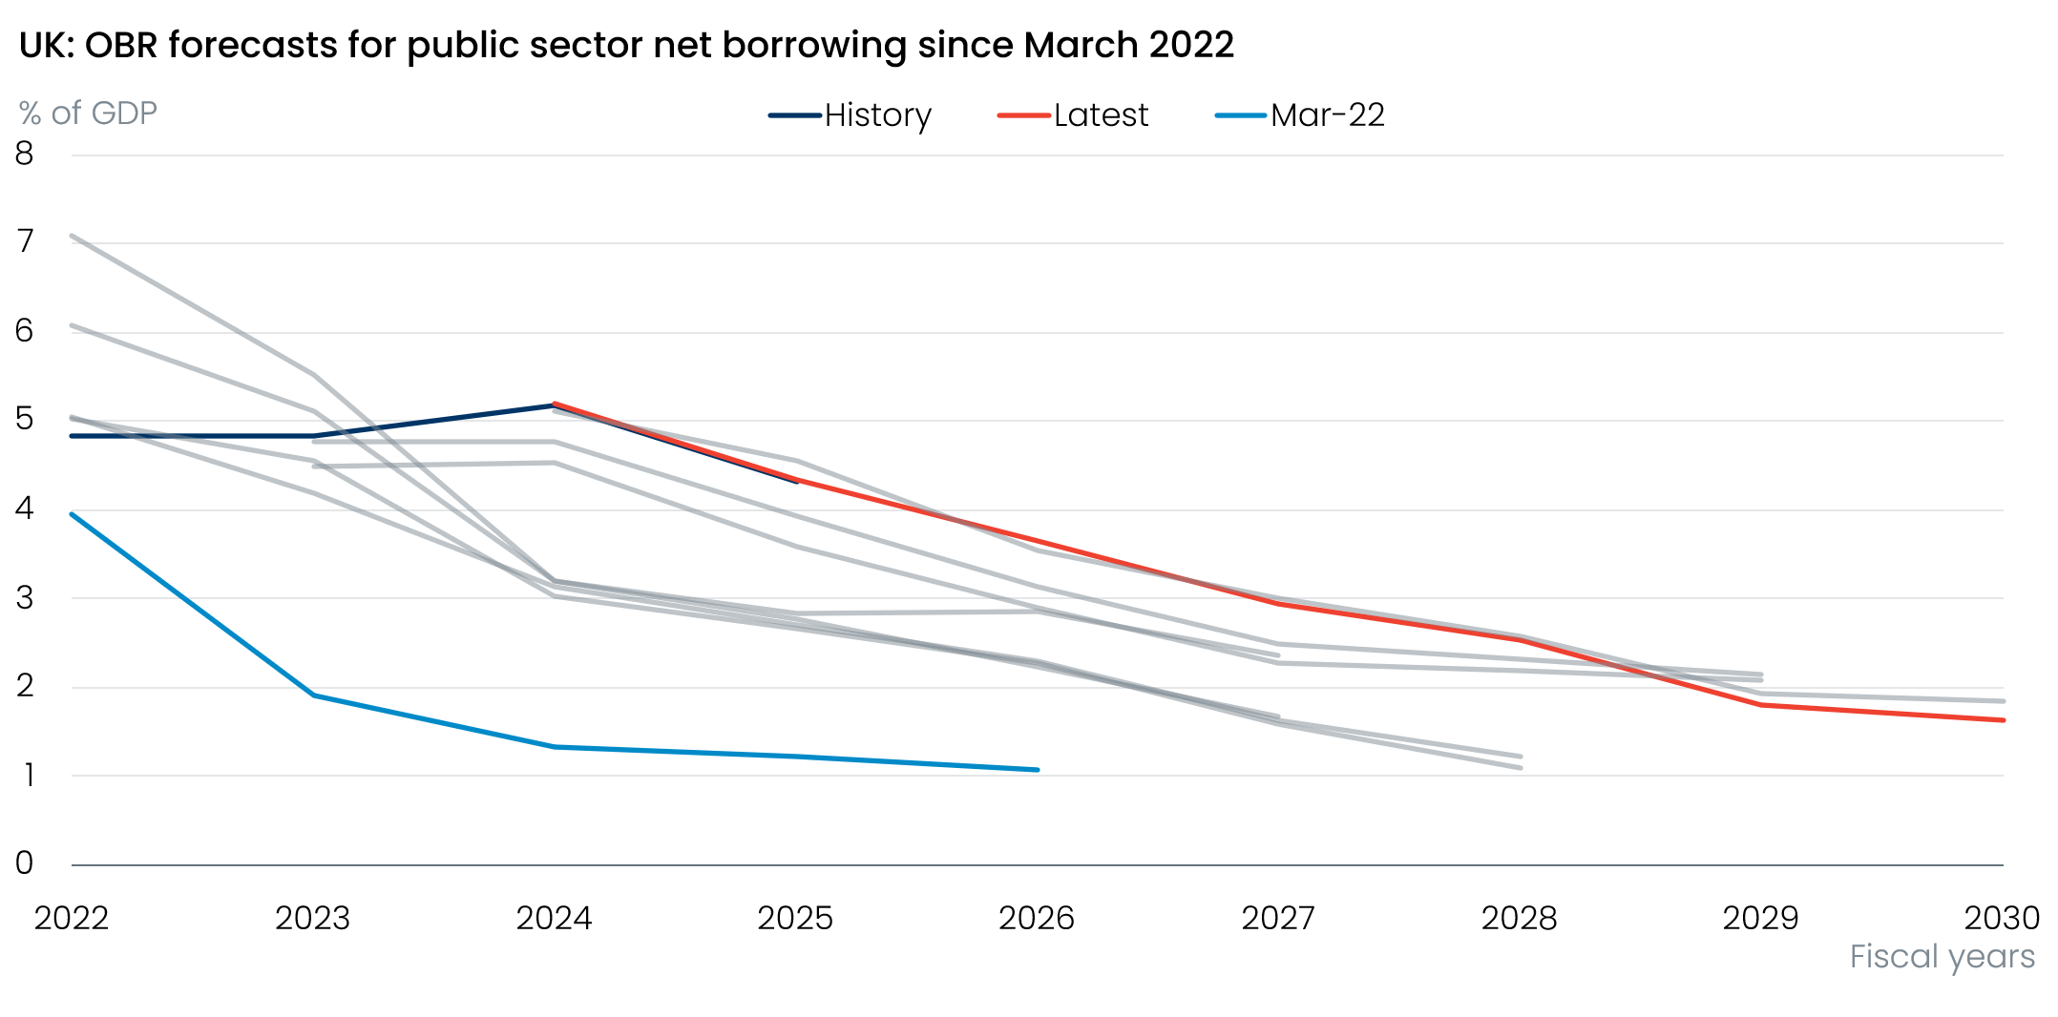
Sources: Oxford Economics, Haver Analytics
This has undermined the credibility of the UK’s commitment to tightening policy by an amount that would be needed to begin reducing the elevated debt level. In our view, a series of other factors raise further questions over whether the current fiscal plans will successfully reduce borrowing:
- Tax rises account for the entire consolidation; history suggests revenue-based consolidations have a higher risk of failure.
- That risk is exacerbated by the focus on attempting to generate large increases in small revenue streams. This may induce behavioural changes, potentially leading to lower-than-anticipated tax receipts.
- The shape of the consolidation and the government’s inability to gain enough support from its own party to pass welfare reforms last year has created the impression the government does not have the will or ability to cut spending.
- A large chunk of the planned tightening is due to take place in the year of the next election, which doesn’t look credible.

Long-running structural problems further undermine market views of the UK
Markets might be willing to offer the UK some leeway if the government had a strong story to tell on its economic plans. But after two years in power, there’s scant evidence the current administration has been able to tackle the long-running structural problems it inherited.
Throughout the period since 2020, UK inflation has been at least as high as the G7 median, and higher for the bulk of the time. Indeed, for roughly half that period, inflation has been higher in the UK than any other G7 nation (Chart 6). This experience has created a perception that UK policymakers struggle to keep a lid on inflationary pressures, particularly when subject to global energy shocks. In a world of more frequent supply shocks, this will maintain upward pressure on the shorter end of the curve.
Chart 6: The UK has consistently experienced higher inflation than other G7 nations
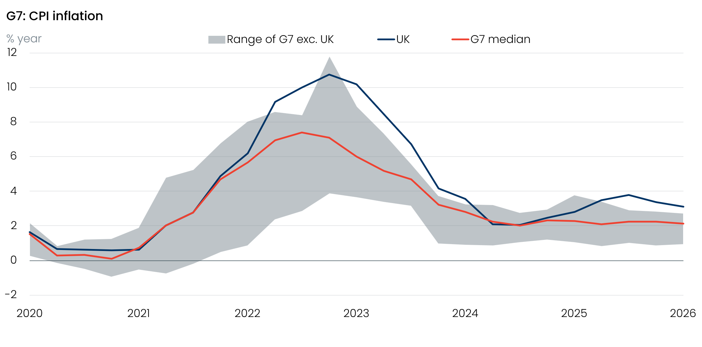
Sources: Oxford Economics, Haver Analytics
The UK’s poor growth performance is another problem – if the UK could achieve stronger economic growth on a sustained basis, it would transform the fiscal outlook. Over the past 20 years, labour supply has grown very strongly, but productivity growth has been dismal. Prior to the GFC, growth in output per hour averaged 2.2% a year (Chart 7). But between the GFC and the pandemic, productivity growth slowed to just 0.3% a year, and since then the pickup has only been marginal to 0.4% a year.
Chart 7: The UK's productivity performance remains poor
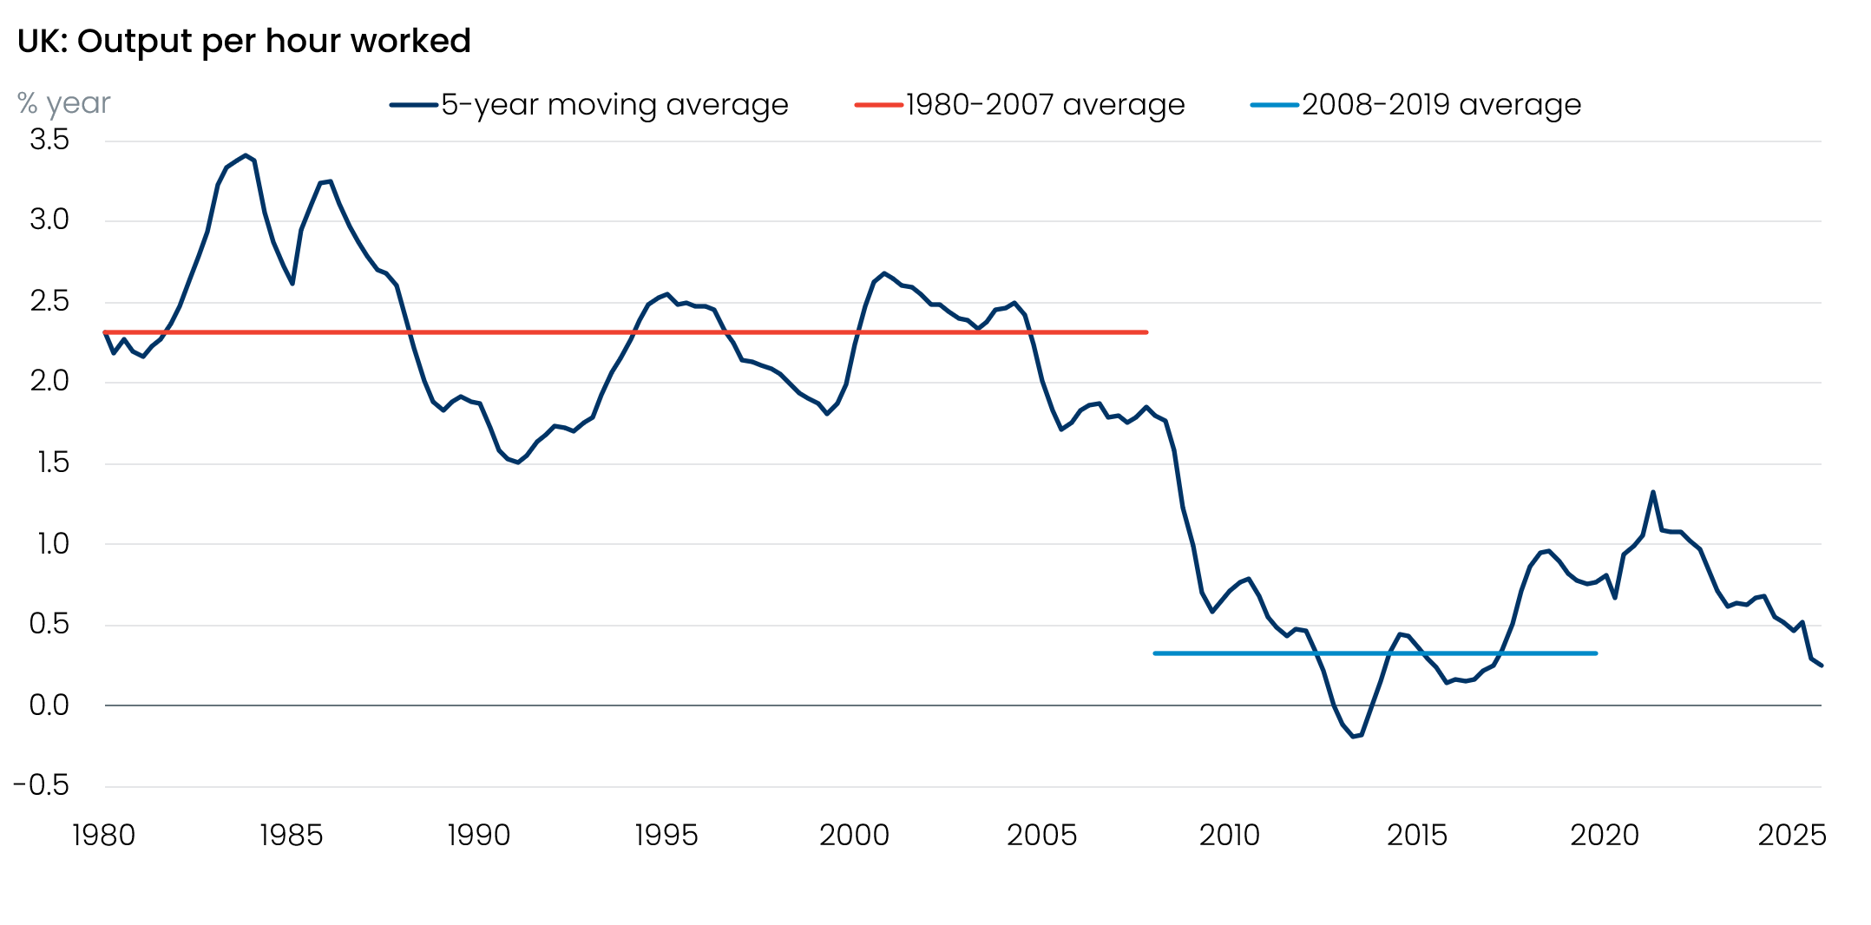
Sources: Oxford Economics, Haver Analytics
Since 2007, the UK economy has endured three huge shocks: the global financial crisis, Brexit, and the coronavirus pandemic. While all three will likely have large, permanent impacts on productivity levels, the impacts of the GFC and pandemic on productivity growth are probably now behind us, while a good chunk of the Brexit effects have already been seen. So avoiding further large unexpected shocks should provide a stronger platform for future productivity growth.
But that factor alone will not be enough. The UK’s ageing population and lower net immigration mean that future GDP growth must rely less on rising labour supply and more on productivity gains. And while the current government has correctly identified the importance of boosting productivity, so far there’s little evidence that its policies will drive a material improvement in private sector productivity. Given plans to improve public services have involved sizeable increases in headcount, the chances of an improvement in public sector productivity look similarly slim. In 2025, public sector productivity was 3.1% lower than it was in 2019.
Regarding how markets’ view the UK’s ability to solve its structural problems, regular bouts of political instability are a further hinderance. The UK has already had four prime minsters in four years, and a fifth before the end of this year seems likely. Even with a majority of more than 150 seats, the government was unable to pass its proposed welfare reforms last year. Political discourse has become more populist in nature, while political support has become more fragmented, with opinion polls showing four parties grouped at 15%-25%. Such an unstable political backdrop is unlikely to provide a platform for growth-enhancing reforms or fiscal savings.

Weak public finances leave the government more vulnerable to shocks
With high debt levels and borrowing, a track record of soft pedalling on fiscal consolidation, and little evidence the country has the ability or political will to tackle its structural problems, a sizeable term premium is likely to be attached to gilts (Chart 8).
Chart 8: UK term premium is likely to rise further in the short-term and then stay elevated
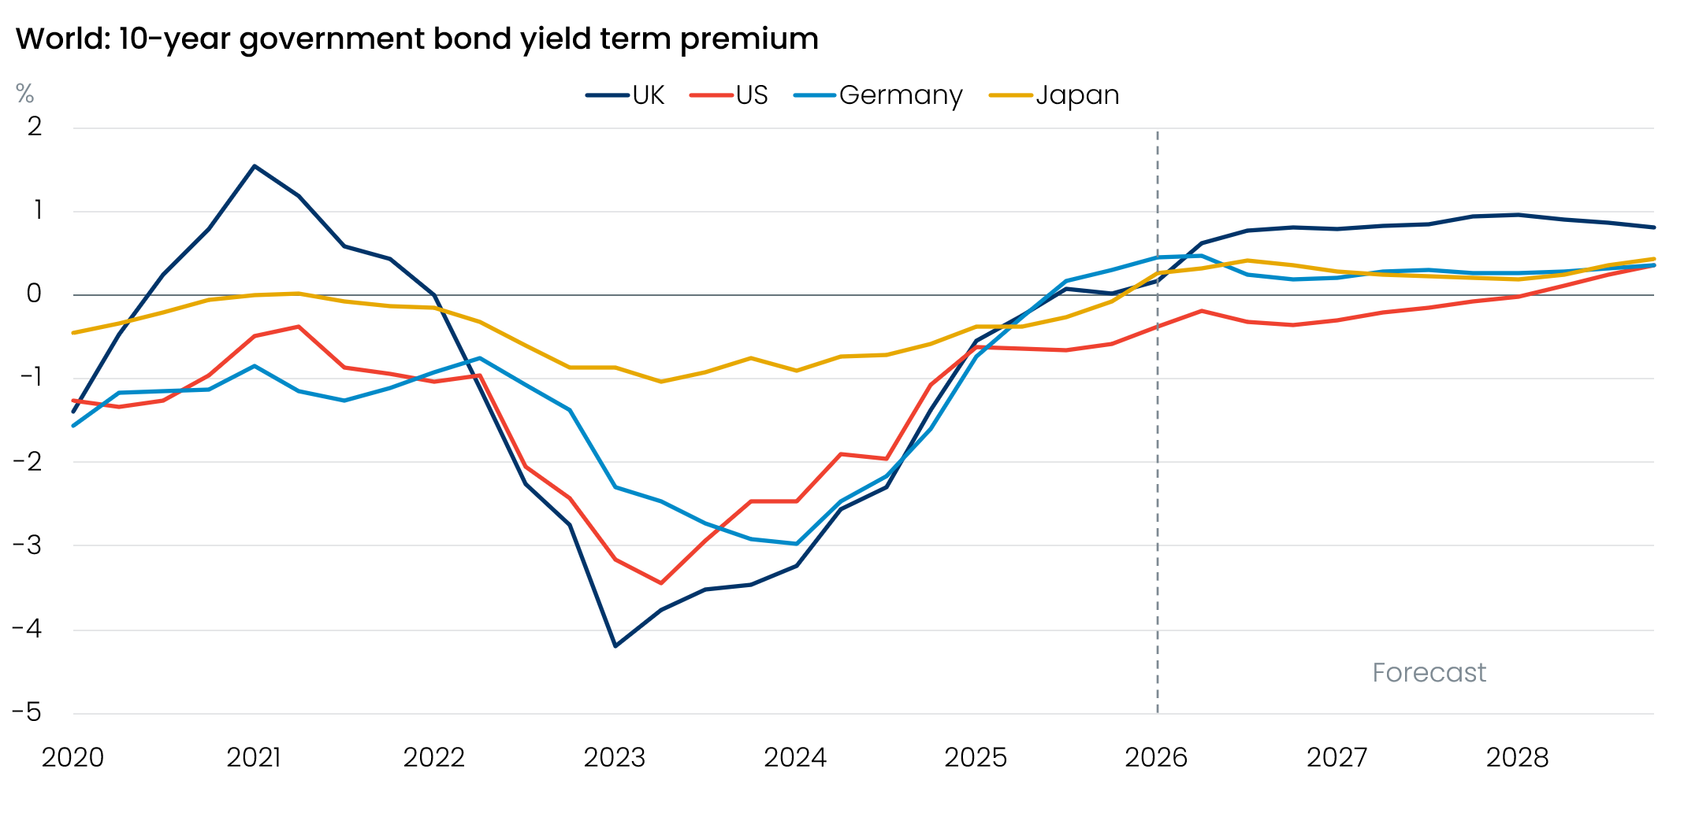
Source: Oxford Economics calculations using data from Haver Analytics
We expect debt servicing costs to be higher than nominal GDP growth over the next five years. Of the advanced economies, only Italy has similarly poor debt dynamics (Chart 1). This leaves the UK highly vulnerable to swings in market sentiment.
But it has also left the UK in a situation where the government has few options to try and cushion the blow to the economy from the energy shock. Given already high levels of borrowing and debt, markets would surely balk at the government offering costly universal support, of the like extended by the Truss government in 2022. So any fiscal support is likely to be small scale and targeted at those most in need. This will do little to mitigate the impact on the economy and means the UK is at high risk of slipping into recession.
Unless the government can tackle its structural problems and improve the state of the public finances, then its current inability to offer much support to the economy could become a template for subsequent shocks.

